## 5.5 Business Rules

* Hospital, labs and medical stores address is accessible in anywhere.
* All the data of patient will be save online for future use.
* To make attractive Graphical User Interface.

# Other Requirements

## 6.1 Decision Tree:

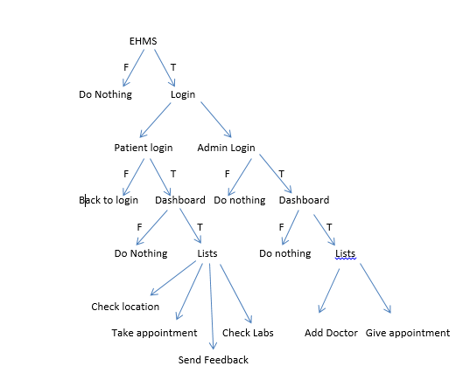

## Flow Chart:

## ER Diagram:

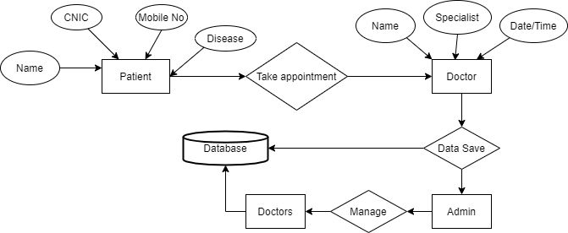

Appendix A: Glossary

EHMS: Electronic Healthcare Management System.

App: application